Supplementary Table 1. Electrophysiological features of neurons.
Feature | Name | Description
ET₁ | Average ISI | Interspike interval (ISI): Difference in time between the time of an action potential and the time of the next consecutive action potential.  Average ISI: The mean value of all interspike intervals in a sweep.
ET₂ | Latency | The time between the start of the stimulus until the time of the first spike evoked by a stimulus.
ET₃ | Adaptation index | The rate at which firing speeds up or slows down during a stimulus, defined as $\frac{1}{N-1}\sum_{n=1}^{N-1}{\frac{τ_{n+1}-τ_{n}}{τ_{n+1}+τ_{n}}}$
ET₄ | I-f curve slope | For all long square responses, the average firing rate and the stimulus amplitude are combined to estimate the curve of the frequency response of the cell versus stimulus intensity (“I-f curve”). The suprathreshold part of this curve is fit to a straight line, and the slope of this line is recorded as a cell-wide feature.
ES₁ | Threshold current for long square | Threshold current upon long square current input. The minimum current amplitude that evokes an action potential (“rheobase”) is used.
ES₂ | Threshold current for ramp | Threshold current under ramp current injection.
ES₃ | Threshold current for short square | Threshold current with short square current input. The current with the lowest amplitude that reliably evokes action potentials is used.
ES₄ | Threshold time for long square | The threshold corresponds to the point before the peak where the dV/dt matches 5% of the average maximal dV/dt across all action potentials in a given sweep.
ES₅ | Threshold time for ramp | That for ramp current injection.
ES₆ | Threshold time for short square | That for short square current injection.
ES₇ | Peak time for long square | Action potential peak: Maximum value of the membrane potential during the action potential (i.e. between the action potential’s threshold and the time of the next action potential, or the end of the response).
ES₈ | Peak time for ramp | That for ramp current injection.
ES₉ | Peak time for short square | That for short square current injection.
ES₁₀ | Trough time for long square | Action potential trough: Minimum value of the membrane potential in the interval between the peak and the time of the next action potential.
ES₁₁ | Trough time for ramp | That for ramp current injection
ES₁₂ | Trough time for short square | That for short square current injection.
ES₁₃ | Fast trough time for long square | Action potential fast trough: Minimum value of the membrane potential in the interval lasting 5 ms after the peak.
ES₁₄ | Fast trough time for ramp | That for ramp current injection.
ES₁₅ | Fast trough time for short square | That for short square current injection.
ES₁₆ | Slow trough time for long square | Action potential slow trough: Minimum value of the membrane potential in the interval from 5 ms after the peak until the time of the next action potential. If the time between the peak and the next action potential is less than 5 ms, this value is identical to the fast trough.
ES₁₇ | Slow trough time for ramp | That for ramp current injection.
ES₁₈ | Slow trough time for short square | That for short square current injection.
ES₁₉ | Threshold voltage for long square | Threshold voltage upon long square current injection.
ES₂₀ | Threshold voltage for ramp | That for ramp current injection.
ES₂₁ | Threshold voltage for short square | That for short square current injection.
ES₂₂ | Peak voltage for long square | Peak voltage upon long square current injection.
ES₂₃ | Peak voltage for ramp | That for ramp current injection.
ES₂₄ | Peak voltage for short square | That for short square current injection.
ES₂₅ | Trough voltage for long square | Trough voltage upon long square current injection.
ES₂₆ | Trough voltage for ramp | That for ramp current injection.
ES₂₇ | Trough voltage for short square | That for short square current injection.
ES₂₈ | Fast trough voltage for long square | Fast trough voltage upon long square current injection.
ES₂₉ | Fast trough voltage for ramp | That for ramp current injection.
ES₃₀ | Fast trough voltage for short square | That for short square current injection.
ES₃₁ | Slow trough voltage for long square | Slow trough voltage upon long square current injection.
ES₃₂ | Slow trough voltage for ramp | That for ramp current injection.
ES₃₃ | Slow trough voltage for short square | That for short square current injection.
ES₃₄ | Upstroke-downstroke ratio for long square | Action potential peak upstroke: The maximum value of dV/dt between the action potential threshold and the action potential peak.  Action potential peak downstroke: The minimum value of dV/dt between the action potential peak and the action potential trough.  Upstroke/downstroke ratio: The ratio between the absolute values of the action potential peak upstroke and the action potential peak downstroke.
ES₃₅ | Upstroke-downstroke ratio for ramp | That for ramp current injection.
ES₃₆ | Upstroke-downstroke ratio for short square | That for short square current injection.
ET₁ to ET₄: spike train-related features; ES₁ to ES₃₆: spike shape-related features.

Supplementary Table 2. Pearson correlation coefficients between structural and electrophysiological features.
 | S₁ | S₂ | S₃ | S₄ | S₅ | S₆ | S₇ | S₈ | S₉ | S₁₀ | S₁₁ | S₁₂ | S₁₃ | S₁₄ | S₁₅ | S₁₆
ES₁ | -0.10 | 0.05 | -0.05 | 0.03 | 0.03 | -0.05 | -0.06 | 0.21 | 0.22 | 0.24 | 0.17 | 0.22 | 0.13 | 0.24 | 0.20 | 0.18
ES₂ | -0.09 | 0.04 | 0.03 | 0.06 | 0.09 | 0.04 | 0.03 | 0.32 | 0.32 | 0.41 | 0.17 | 0.32 | 0.22 | 0.41 | 0.37 | 0.33
ES₃ | -0.15 | -0.03 | 0.24 | 0.03 | 0.43 | 0.36 | 0.37 | 0.69 | 0.70 | 0.75 | 0.30 | 0.70 | 0.32 | 0.75 | 0.68 | 0.60
ES₄ | 0.08 | 0.00 | 0.00 | 0.02 | -0.03 | -0.08 | -0.07 | 0.06 | 0.06 | -0.01 | 0.09 | 0.07 | 0.01 | -0.01 | -0.01 | 0.01
ES₅ | -0.09 | 0.04 | 0.03 | 0.06 | 0.09 | 0.04 | 0.03 | 0.32 | 0.32 | 0.41 | 0.17 | 0.32 | 0.22 | 0.41 | 0.37 | 0.33
ES₆ | 0.10 | 0.00 | 0.07 | 0.07 | -0.05 | -0.05 | -0.05 | -0.03 | -0.03 | -0.03 | 0.01 | -0.03 | 0.00 | -0.03 | -0.01 | 0.00
ES₇ | 0.08 | 0.00 | 0.00 | 0.02 | -0.03 | -0.08 | -0.07 | 0.06 | 0.06 | -0.01 | 0.09 | 0.07 | 0.01 | -0.01 | -0.01 | 0.01
ES₈ | -0.09 | 0.04 | 0.03 | 0.06 | 0.09 | 0.04 | 0.03 | 0.32 | 0.32 | 0.41 | 0.17 | 0.32 | 0.22 | 0.41 | 0.37 | 0.33
ES₉ | 0.10 | -0.01 | 0.09 | 0.08 | -0.02 | -0.02 | -0.02 | 0.00 | 0.00 | 0.01 | 0.02 | 0.00 | 0.01 | 0.01 | 0.03 | 0.03
ES₁₀ | 0.05 | 0.00 | 0.01 | 0.01 | 0.04 | -0.01 | -0.01 | 0.12 | 0.13 | 0.06 | 0.09 | 0.13 | -0.01 | 0.07 | 0.05 | 0.04
ES₁₁ | -0.09 | 0.04 | 0.03 | 0.06 | 0.09 | 0.04 | 0.03 | 0.32 | 0.32 | 0.41 | 0.17 | 0.33 | 0.22 | 0.41 | 0.37 | 0.33
ES₁₂ | 0.02 | 0.00 | -0.10 | 0.01 | -0.31 | -0.29 | -0.30 | -0.27 | -0.27 | -0.33 | -0.12 | -0.27 | -0.18 | -0.34 | -0.29 | -0.24
ES₁₃ | 0.08 | 0.00 | 0.00 | 0.02 | -0.03 | -0.08 | -0.07 | 0.06 | 0.06 | -0.01 | 0.09 | 0.07 | 0.01 | -0.01 | -0.01 | 0.01
ES₁₄ | -0.09 | 0.04 | 0.03 | 0.06 | 0.09 | 0.04 | 0.03 | 0.32 | 0.32 | 0.41 | 0.17 | 0.32 | 0.22 | 0.41 | 0.37 | 0.33
ES₁₅ | 0.06 | -0.05 | 0.11 | 0.07 | 0.12 | 0.10 | 0.11 | 0.15 | 0.15 | 0.11 | 0.08 | 0.15 | 0.02 | 0.11 | 0.11 | 0.10
ES₁₆ | 0.20 | 0.00 | -0.05 | 0.04 | -0.12 | -0.19 | -0.18 | -0.01 | -0.01 | -0.12 | -0.01 | -0.01 | -0.08 | -0.10 | -0.09 | -0.05
ES₁₇ | -0.08 | -0.03 | 0.08 | 0.06 | 0.30 | 0.17 | 0.17 | 0.53 | 0.52 | 0.54 | 0.11 | 0.51 | 0.20 | 0.55 | 0.48 | 0.41
ES₁₈ | 0.04 | -0.04 | 0.07 | 0.08 | -0.32 | -0.21 | -0.23 | -0.25 | -0.25 | -0.22 | -0.13 | -0.25 | 0.02 | -0.22 | -0.09 | -0.06
ES₁₉ | 0.07 | -0.01 | -0.08 | -0.03 | -0.06 | -0.10 | -0.11 | -0.06 | -0.05 | -0.14 | 0.07 | -0.05 | -0.10 | -0.14 | -0.13 | -0.10
ES₂₀ | 0.05 | 0.02 | -0.24 | -0.07 | -0.26 | -0.29 | -0.31 | -0.27 | -0.27 | -0.36 | 0.01 | -0.26 | -0.15 | -0.37 | -0.35 | -0.30
ES₂₁ | 0.15 | -0.05 | -0.02 | 0.13 | -0.25 | -0.26 | -0.26 | -0.23 | -0.24 | -0.30 | -0.14 | -0.24 | -0.11 | -0.30 | -0.22 | -0.16
ES₂₂ | -0.02 | -0.16 | 0.29 | 0.04 | 0.47 | 0.47 | 0.49 | 0.45 | 0.44 | 0.51 | 0.04 | 0.43 | 0.16 | 0.52 | 0.47 | 0.40
ES₂₃ | -0.08 | -0.10 | 0.21 | -0.05 | 0.48 | 0.44 | 0.46 | 0.45 | 0.44 | 0.46 | 0.10 | 0.44 | 0.11 | 0.46 | 0.40 | 0.33
ES₂₄ | -0.03 | -0.14 | 0.22 | 0.02 | 0.46 | 0.42 | 0.44 | 0.45 | 0.44 | 0.48 | 0.07 | 0.43 | 0.11 | 0.48 | 0.42 | 0.34
ES₂₅ | -0.03 | -0.06 | 0.00 | 0.00 | 0.25 | 0.17 | 0.16 | 0.24 | 0.23 | 0.11 | -0.01 | 0.23 | -0.09 | 0.11 | 0.09 | 0.07
ES₂₆ | 0.00 | -0.03 | -0.07 | 0.00 | 0.17 | 0.05 | 0.05 | 0.14 | 0.13 | 0.00 | -0.08 | 0.12 | -0.14 | 0.00 | -0.01 | -0.01
ES₂₇ | 0.06 | -0.09 | 0.23 | 0.20 | 0.12 | 0.25 | 0.26 | 0.13 | 0.12 | 0.26 | -0.14 | 0.10 | 0.19 | 0.27 | 0.30 | 0.27
ES₂₈ | -0.06 | -0.04 | -0.03 | -0.13 | 0.42 | 0.27 | 0.28 | 0.40 | 0.41 | 0.21 | 0.20 | 0.41 | -0.09 | 0.20 | 0.13 | 0.09
ES₂₉ | -0.03 | -0.03 | -0.14 | -0.17 | 0.29 | 0.12 | 0.13 | 0.24 | 0.24 | -0.01 | 0.15 | 0.24 | -0.17 | -0.01 | -0.07 | -0.08
ES₃₀ | -0.07 | -0.06 | 0.05 | -0.10 | 0.41 | 0.31 | 0.32 | 0.42 | 0.43 | 0.29 | 0.18 | 0.43 | -0.01 | 0.29 | 0.23 | 0.18
ES₃₁ | -0.06 | 0.09 | -0.14 | 0.05 | -0.19 | -0.16 | -0.17 | -0.22 | -0.22 | -0.17 | -0.13 | -0.22 | 0.00 | -0.17 | -0.14 | -0.11
ES₃₂ | -0.04 | 0.00 | -0.06 | -0.02 | 0.03 | -0.07 | -0.08 | -0.03 | -0.04 | -0.10 | -0.12 | -0.05 | -0.07 | -0.10 | -0.09 | -0.07
ES₃₃ | 0.18 | -0.12 | -0.06 | 0.15 | 0.06 | 0.02 | 0.03 | 0.02 | 0.00 | -0.04 | -0.13 | -0.01 | -0.09 | -0.04 | -0.07 | -0.06
ES₃₄ | -0.07 | -0.09 | 0.13 | -0.04 | 0.45 | 0.40 | 0.42 | 0.48 | 0.47 | 0.41 | 0.16 | 0.47 | 0.06 | 0.42 | 0.34 | 0.27
ES₃₅ | -0.06 | -0.08 | 0.14 | -0.04 | 0.40 | 0.35 | 0.36 | 0.44 | 0.44 | 0.37 | 0.16 | 0.44 | 0.06 | 0.38 | 0.32 | 0.26
ES₃₆ | -0.09 | -0.07 | 0.11 | -0.09 | 0.46 | 0.44 | 0.45 | 0.47 | 0.47 | 0.41 | 0.16 | 0.46 | 0.03 | 0.41 | 0.33 | 0.26
ET₁ | -0.03 | -0.08 | 0.18 | 0.03 | 0.32 | 0.27 | 0.28 | 0.31 | 0.31 | 0.32 | 0.11 | 0.30 | 0.14 | 0.32 | 0.31 | 0.26
ET₂ | -0.06 | 0.01 | 0.08 | -0.01 | 0.14 | 0.15 | 0.15 | 0.30 | 0.31 | 0.29 | 0.23 | 0.31 | 0.16 | 0.30 | 0.26 | 0.23
ET₃ | -0.06 | -0.07 | 0.17 | 0.06 | 0.17 | 0.26 | 0.26 | 0.23 | 0.22 | 0.41 | -0.04 | 0.21 | 0.14 | 0.41 | 0.39 | 0.34
ET₄ | 0.09 | 0.07 | -0.14 | 0.04 | -0.40 | -0.38 | -0.39 | -0.40 | -0.39 | -0.36 | -0.02 | -0.38 | -0.08 | -0.36 | -0.31 | -0.26

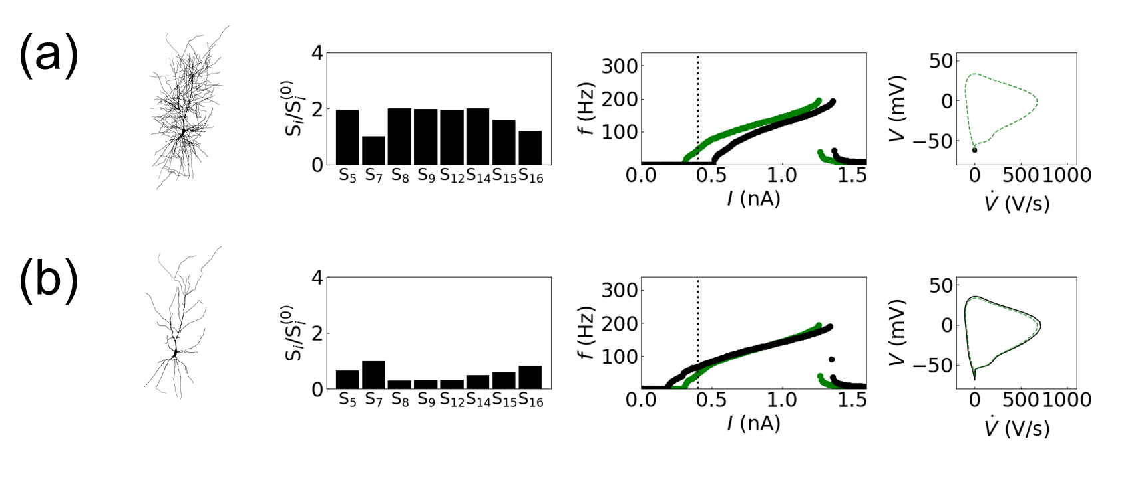
Supplementary Fig. 1. Influence of structural changes in the CA1 pyramidal neuron dynamics: (a) adding additional dendritic branches and (b) deleting dendritic branches. The first column displays the modified model structures, followed by the characterization of modified structures using the primary structural features of the Allen Cell Types Database (the second column) and the I-f curves (the third column). The I-f curves of the original structure and the modified structure are plotted in green and black, respectively. The last column exhibits the phase portrait on the V-V̇ plane at I = 0.4 nA. The black solid line/dot and the green dashed line represent the results with and without structural changes, respectively.

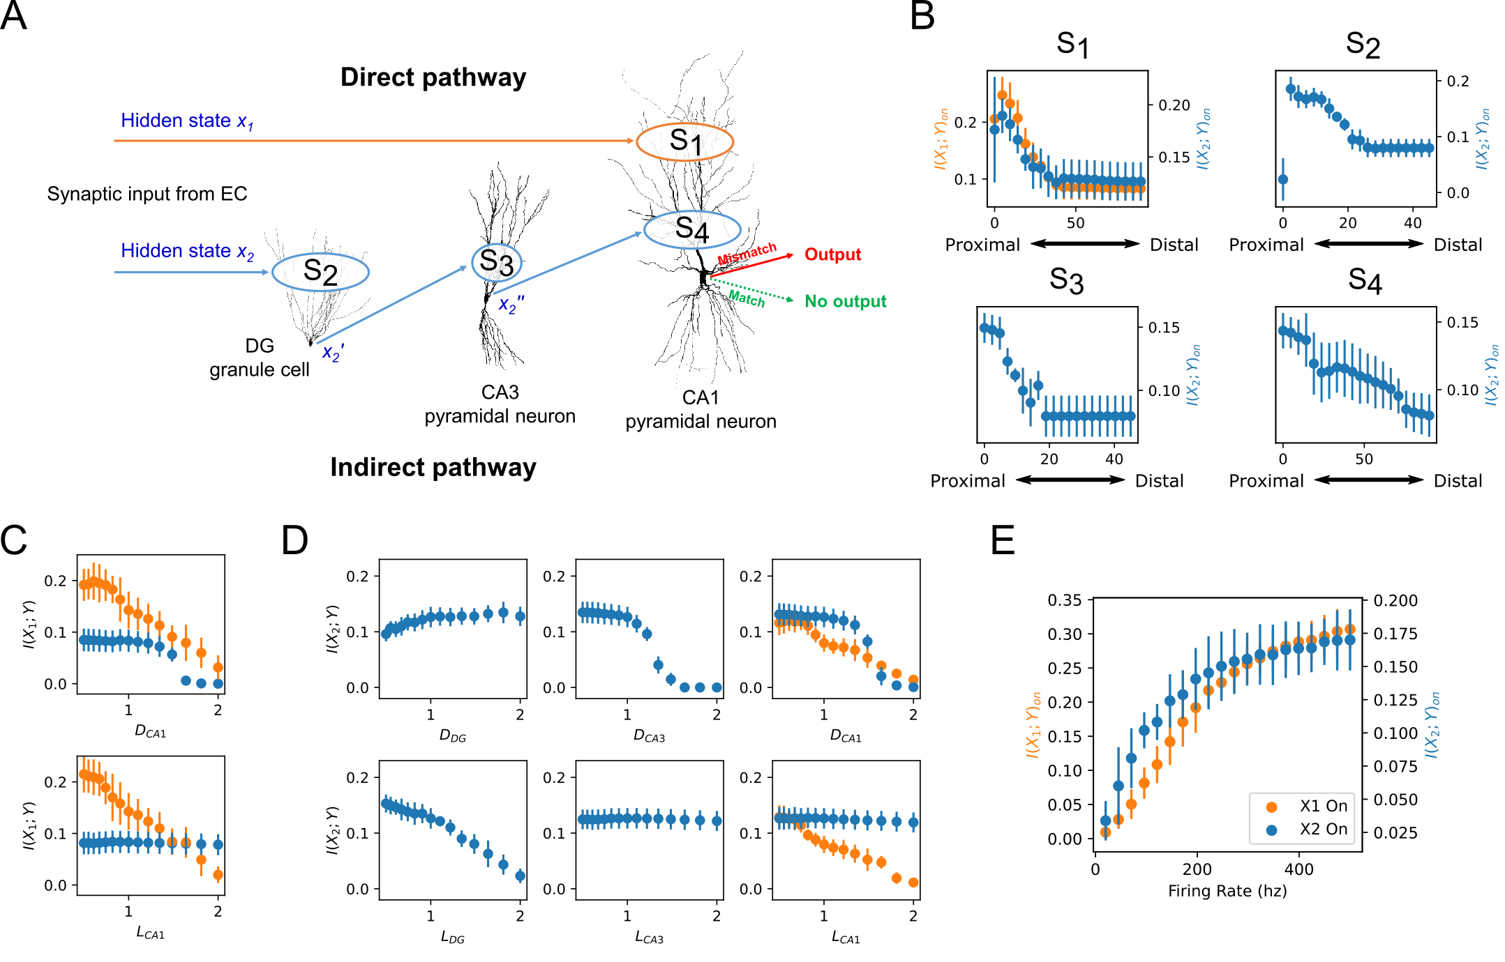

Supplementary Fig. 2. (a) Schematic diagram of a neural circuit constructed using DG granule cell and CA1 and CA3 pyramidal neurons. Two hidden states $x_{1}$ and $x_{2}$ provide input and are coupled with a coherence parameter $α=0.9$. Hidden state $x_{1}$ stimulates a distal region of CA1 neuron dendrite at synapse $S_{1}$. Hidden state $x_{2}$ stimulates DG at synapse $S_{2}$, which transmits the signal to CA3 at synapse $S_{3}$ to CA1 at proximal synapse $S_{4}$. CA1 integrates both inputs and outputs a signal only when there is a mismatch. (b) The effect of synapse location on mutual information between each hidden state and the output of CA1 for the direct pathway (orange) and the indirect pathway (blue) when both pathways are on. The x-axis indicates the distance from the soma where a smaller value corresponds to proximal placement. (c) The effect of changes in dendrite length (L_{CA1}) and diameter of CA1 (D_{CA1}) to the mutual information between hidden state $x_{1}$ and CA1 output y when only $x_{1}$ is on (orange) and only $x_{2}$ is on (blue). The x-axis indicates the scaling factor to the default values. (d) The effect of changes in dendrite length and diameter for neurons in the indirect pathway (D_{DG}: DG diameter, D_{CA3}: CA3 diameter, L_{DG}: DG length, L_{CA3}: CA3 length) to the mutual information between hidden state $x_{2}$ and CA1 output y when only $x_{1}$ is on (orange) and only $x_{2}$ is on (blue). The x-axis indicates the scaling factor to the default values. (e) The effect of changes in the hidden state firing rate to the mutual information between CA1 output y and each hidden state when only $x_{1}$ is on (orange) and only $x_{2}$ is on (blue).

Mathematical model for neocortical layer 5 pyramidal neuron
The neuron model for a neocortical layer 5 pyramidal neuron is systemically analyzed (Fig. S.3). The model was developed by Hay et al. (ModelDB accession 139653) [1] to faithfully reproduce the perisomatic Na⁺-spiking behavior and the key dendritic active currents, including Ca²⁺ spikes and back-propagating action potentials. The model describes realistic structures via three-dimensional morphological reconstruction of biological neurons. It includes nine ion channels to faithfully reproduce both perisomatic Na⁺ and dendritic Ca²⁺ firing behaviors [56, 57], wherein six types of ionic currents (i.e., fast inactivating sodium current, persistent sodium current, muscarinic potassium current, slow inactivating potassium current, fast inactivation potassium current, and fast/non-inactivating potassium current) are uniformly distributed, while three types (i.e., non-specific cation current, high voltage-activated calcium current and low voltage-activated calcium current) are nonuniformly distributed (see [1] for more details). The membrane capacitance C_{m} is set equal to 1 μF/cm² for the soma and axon, and 2 μF/cm² for the basal and apical dendrites to correct for dendritic spine area [2, 3]. Axial resistance (R_{i}) is set to be 100 Ω∙cm for all compartments [4]. Channel kinetics and densities are adjusted at temperature 34°C. All simulations have been performed via the NEURON program (v7.8) [5, 6] with a time step of 0.01 ms.

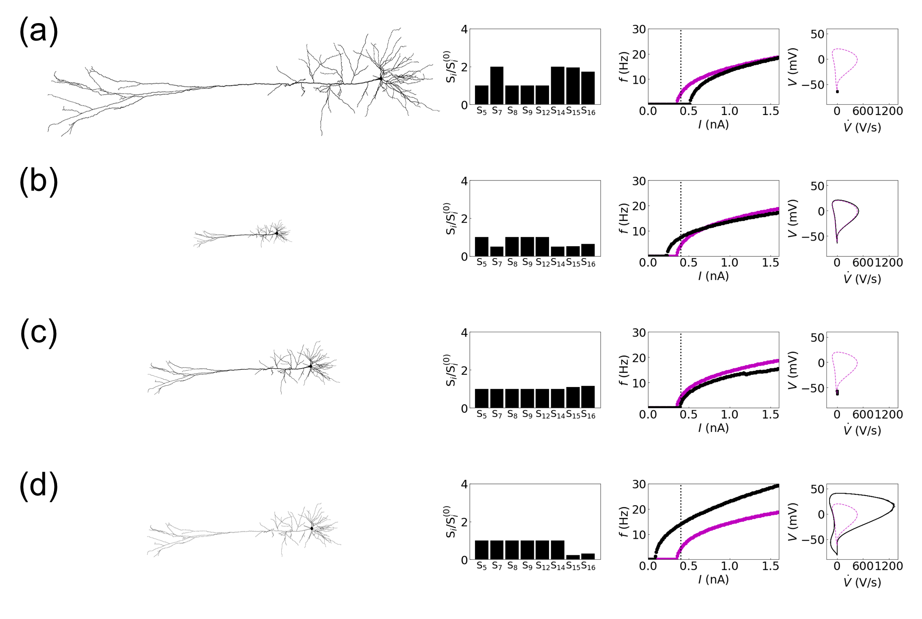
Supplementary Fig. 3. Influence of structural changes in the neocortical layer 5 pyramidal neuron dynamics: (a) 2-fold increase and (b) 0.5-fold decrease in the dendritic length, and (c) 1.1-fold increase and (d) 0.2-fold decrease in the dendritic diameter. The first column displays the modified model structures, followed by the characterization of modified structures using the primary structural features of the Allen Cell Types Database (the second column) and the I-f curves (the third column). The I-f curves of the original structure and the modified structure are plotted in magenta and black, respectively. The last column exhibits the phase portrait on the V-V̇ plane at I = 0.4 nA. The black solid line/dot and the magenta dashed line represent the results with and without structural changes, respectively.

References
1. Hay E, Hill S, Schürmann F, Markram H, Segev I. Models of Neocortical Layer 5b Pyramidal Cells Capturing a Wide Range of Dendritic and Perisomatic Active Properties. PLOS Computational Biology. 2011;7(7):e1002107. doi: 10.1371/journal.pcbi.1002107.
2. Holmes WR, Rall W. Estimating the electrotonic structure of neurons with compartmental models. Journal of Neurophysiology. 1992;68(4):1438-52. doi: 10.1152/jn.1992.68.4.1438. PubMed PMID: 1432091.
3. Larkman AU. Dendritic morphology of pyramidal neurones of the visual cortex of the rat: III. Spine distributions. 1991;306(2):332-43. doi: https://doi.org/10.1002/cne.903060209.
4. Stuart G, Spruston N. Determinants of Voltage Attenuation in Neocortical Pyramidal Neuron Dendrites. Journal of Neuroscience. 1998;18(10):3501-10. doi: 10.1523/JNEUROSCI.18-10-03501.1998 %J The Journal of Neuroscience.
5. Carnevale NT, Hines ML. The NEURON book. Cambridge. 2006.
6. Hines ML, Carnevale NT. The NEURON Simulation Environment. Neural Computation. 1997;9:1179-209. doi: 10.1162/neco.1997.9.6.1179.

